Name: _____________________ Class:__________ Date:__________
Instructions: Write answers in the right-hand column. Score: ___________ / 50 marks
Section A— Multiple choice (10 marks)
 | The key event in the life cycle of an organism that relates to the survival of the species is:  A birth.  B fertilisation.  C growth.  D reproduction. | D | 1
 | Development refers to:  A an increase in the body size of an organism as it grows inside its mother.  B changes in body shape and structure as an organism matures.  C the stages in the life cycle of an organism between when it reproduces and when it dies.  D the development of body structures that enable an organism to reproduce. | b | 1
 | Hermaphrodites are individuals who:  A produce both male and female sex cells.  B reproduce asexually.  C produce sex cells that can fertilise other sex cells.  D have male or female sex organs. | A | 1
 | Which of the following methods of reproduction produces the greatest differences between offspring?  A budding  B spore formation  C fertilisation of gametes  D vegetative reproduction | C | 1
 | Which one of the following reproduces using spores?  A frog  B fern  C hydra  D flowering plant | B | 1
 | Which of the following statements is correct?  A Ovulation refers to the release of egg cells from the uterus.  B Fertilisation refers to the production of female gametes.  C Menstruation refers to the shedding of the lining of the ovaries.  D Gestation refers to the time between fertilisation and birth. | D | 1
 | The site of fertilisation of the human egg cell is the:  A ovary.  B fallopian tubes.  C uterus.  D vagina. | b | 1
 | Which of the following shows the events of reproduction in their correct order?  - copulation, ejaculation, fertilisation, implantation  - ejaculation, fertilisation, copulation, implantation  - implantation, ejaculation, fertilisation, copulation  - copulation, ejaculation, implantation, fertilisation | A | 1
 | The human male organ in which sperm are produced is the:  A scrotum  B testes  C epididymis  D penis | B | 1
 | Comparing their roles in reproduction, which of the following in humans is most like the seed in a flowering plant?  A egg  B ovary  C embryo  D sperm | C | 1

Section B— Short answer (30 marks)
- ` | Explain the difference between sexual and asexual reproduction, using a named example of each. | Sexual reproduction requires two gametes (sex cells) joining together and then growing into a new individual.  For example, in humans a sperm and an egg must join before an embryo can be produced.  In asexual reproduction the new individual grows from part of one parent’s body and does not involve joining of gametes.  For example, a young hydra grows from the side of one adult, then breaks off when it is fully formed. | 4
 | Flowering plants may either be self-fertilised or cross-fertilised.  a Describe one feature of plants that ensures cross-fertilisation will occur.  b Clarify the advantage of cross-fertilisation. | a Anther and stigma of each flower mature at different times.  b The offspring will show greater differences and this will improve the chances of survival of the species in a changing environment. | 3
 | State the length of time (in days) for each of the following:  a the typical menstrual cycle in humans  b human gestation  c the number of days taken for a fertilised egg to reach the uterus. | a 28 days  b 266 days  c 5 days | 3
 | Customs officers help prevent the entry of disease-causing organisms and pests into a country. Imagine a customs officer has found some plant material in a passenger’s luggage. Explain how the customs officer would use their knowledge of insect life cycles to check the plant material. | Insects can live in several different life stages. There could be eggs, larvae or pupae.  Just looking for adult insects on the outside of the material will not prevent entry of the insect. There could be other life stages inside it or on it. | 2
 | a Describe the role of a flower.  b Explain the meaning of a ‘fruit’ when referring to any flowering plant.  c Identify which of the following are fruits: orange, ‘gumnut’, peanut (in its shell), watermelon, capsicum. | a to produce seeds for reproduction  b the remains of the ovary and the seeds it contains  c they are all fruits | 3
 | Explain why the human species can survive by a process of reproduction that usually involves only one ‘egg’ each mating, whereas a frog species produces thousands of eggs each time it mates. | Frogs give their offspring very little parental care, so almost all of the eggs or young will die.  Therefore, a large number need to be produced to make sure at least some survive to breeding.  Humans give their young a great deal of parental care so there is a very high survival rate of offspring. | 3
 | Describe the role of the placenta in human reproduction. | The placenta allows the waste materials such as carbon dioxide from the developing baby to be removed.  The placenta also enables materials the baby needs such as oxygen and sugar to pass into the baby from the mother’s circulation. | 2
 | If a woman’s menstrual cycle, was generally 35 days long, calculate:  a on what day of the last cycle she ovulated  b whether she will be closer to 39, 40 or 41 weeks pregnant when she gives birth  c when her level of the hormone LH was highest in her last cycle  d when the egg implanted in her last cycle. | a day 21  b 41 weeks  c day 21  d day 26 | 4
 | Distinguish between ‘fertilisation’ and ‘pregnancy’. | Fertilisation occurs when the sperm and egg join to form the first cell of a new individual.  The cell divides many times to become a blastocyst, which burrows into the wall of the uterus, a process called implantation.  Then the woman can be said to be pregnant. | 3
 | Compare the role in reproduction of:  a anthers and testes  b oviduct and style  c stigma and vagina | a Anthers produce the male sex cells in plants, and the testes do the same role in humans  b The oviduct carries an egg from the ovary to the uterus, while the style allows the male sex cell to grow down into the ovary.  c The stigma receives the pollen, while the vagina receives the sperm | 3

Section C— Thinking scientifically (10 marks)

Information for Question 1 and 2
An experiment on germination was set up as shown in the diagram below.
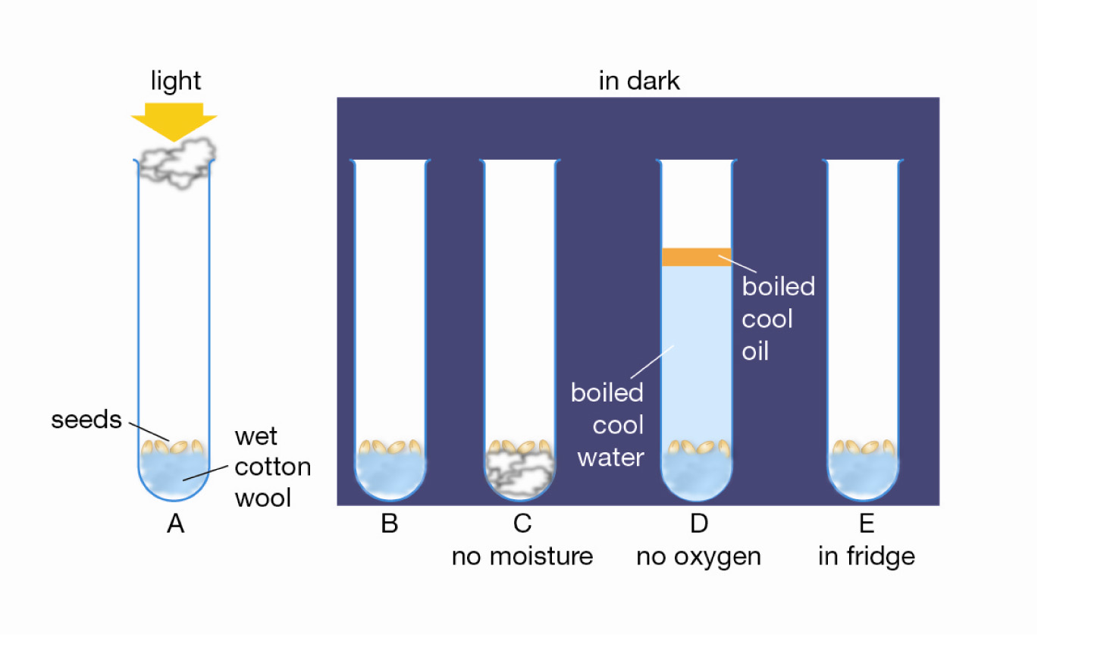

- 1 | To deduce the effect of oxygen on germination, the two tubes that must be compared are:  A B and C  B A and D  C D and E  D B and D | D
 | Which test tube acts as a control for test tube E when deducing the effect of temperature on germination?  A Tube A  B Tube B  C Tube C  D Tube D | B
 | Consider the following diagram.  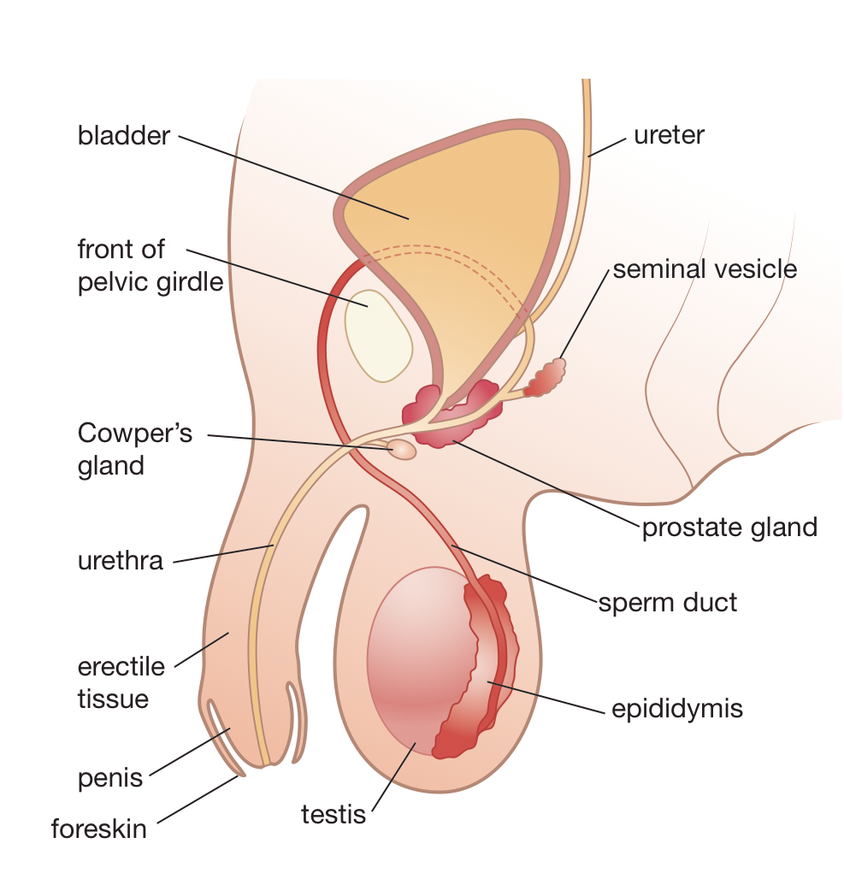  Men can be sterilised in an operation called vasectomy, where the sperm duct (vas deferens) is cut. Which of the following would be the result of this?  A sperm could no longer enter the semen  B sperm could no longer be produced  C no materials could enter the semen from the prostate gland  D semen could no longer pass into the urethra | A
 | Women can be sterilised by cutting and tying the oviducts. Which of the following would be a consequence of this action?  A ova (eggs) would no longer be produced  B ova could not be fertilised by sperm  C fertilised eggs could no longer reach the uterus  D the blastocyst can no longer implant | B
 | The following diagram shows a species of flowering plant called a kangaroo paw. It produces a large amount of nectar near the ovary.  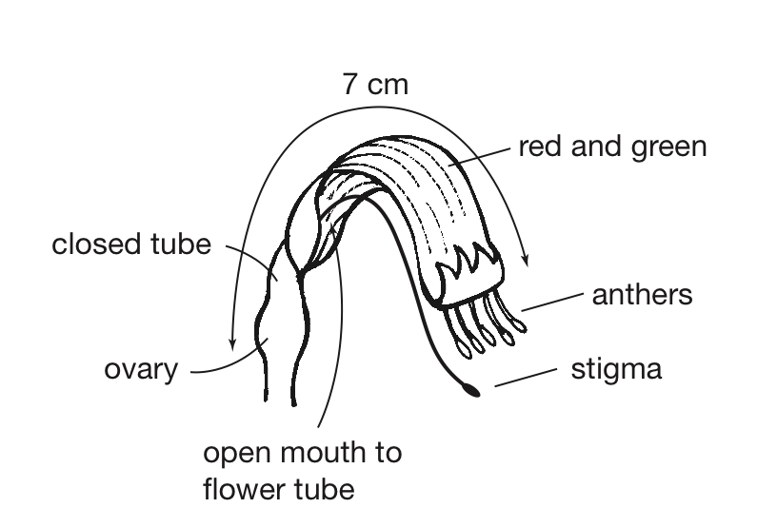  Which of the following predictions is supported by the structure of this flower? The flower is:  A wind pollinated because the anthers are large and the flower is brightly coloured  B self pollinated because it has the anthers and stigma close together  C cross pollinated by insects because the flower is large enough to provide lots of food  D bird pollinated because the anthers and stigma are a long way from the nectar source | D
 | Aphids have separate male and female individuals. Aphids often reproduce by parthenogenesis, during which females produce eggs that turn into young aphids. However, this is an example of asexual reproduction. The explanation for this classification must be that:  A asexual reproduction involves making eggs.  B male aphids do not produce sperm.  C the eggs were never fertilised.  D aphids do not reproduce sexually. | C
 | From the following list predict which would show the greatest differences amongst themselves.  A aphids produced by parthenogenesis from one parent  B potato plants grown from one parent plant  C seedlings from the seeds of one flower  D moss plants grown from one spore case | C
 | The table lists some reproductive structures in humans and in flowering plants.  Which of the following pairs in the table shows the parts that have the same role in human reproduction as they do in the plant reproduction?  A pairs 3 and 5  B pairs 3, 5 and 6  C pairs 4, 5 and 6  D pairs 1 and 3 | D
  Pair number | Human part | Flowering plant part
  1 | testis | anther
  2 | uterus | seed
  3 | sperm | pollen
  4 | egg | fruit 6
  5 | embryo | ovule
  6 | fallopian tube | style 1
 | Which of the following behaviours of a pregnant woman would have the most impact on the brain development of her baby?  A eating lots of fatty foods such as hamburgers throughout the pregnancy  B drinking lots of fizzy drinks throughout the pregnancy  C exercising and doing strenuous housework early in the pregnancy  D regularly drinking alcohol early in the pregnancy | D
 | The following graph shows how body proportions change through life.  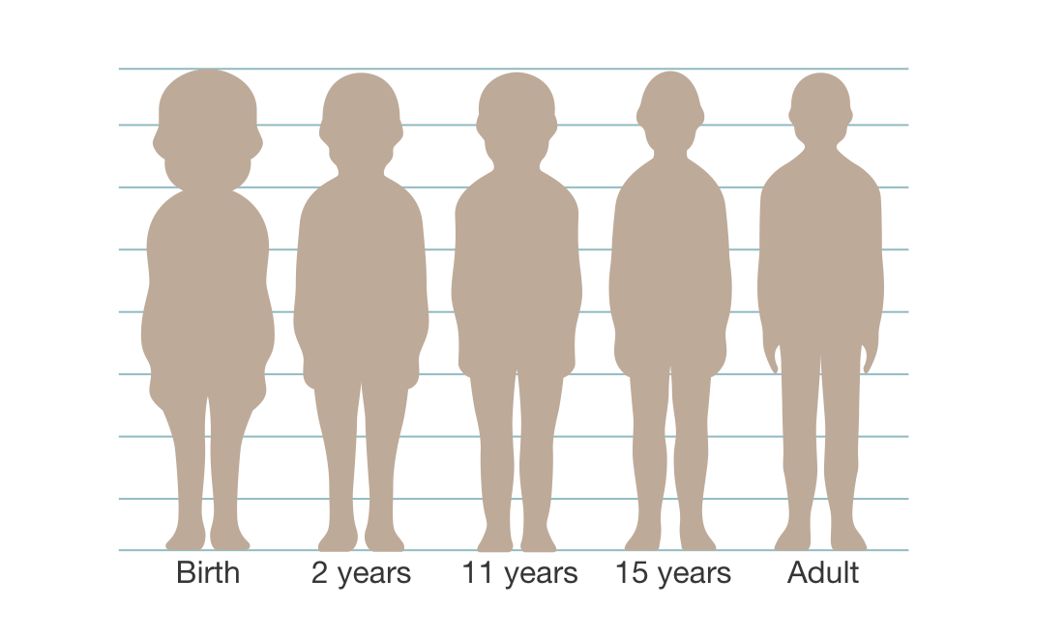  The head of a newborn baby is large in proportion to the rest of its body. An explanation for this is:  A the brain is vital for early development and functioning  B a baby does not need to be able to walk when it is born  C the baby’s head grows faster than the rest of the body once it is born  D the brain becomes less important for survival as a person grows to adulthood | A

